Participant can choose to fill the online application form and submit entry through Internet. Please visit Cyber Security Information Portal (www.cybersecurity.hk/en/contest-2018.php) for detail.

Participant Particulars:
Category: | Open  Category | Family Category^ | Secondary  School Category | Primary  School Category

Name (English)*: |  | (Chinese)*:
Contact Number:
Email Address:
Name of School#:
^ Adult should be participant for Family category
* English and Chinese name should be identical to that appeared in HKID card
# Applicable to Secondary/Primary School Category only
Group Members (if applicable):
 | Name (Chinese) * | Name (English) *

Entry Details:
Name of Video Ad:
Introduction of the
Video Ad:
(Less than 150 words)

How to Submit:
- Submission Period: 30 April 2018 to 27 July 2018 (Late submissions will not be accepted)
- Online Submission: Please visit the Cyber Security Information Portal (www.cybersecurity.hk/en/contest-2018.php) for detail.
- Submission by email: The scanned application form (in PDF format) together with the work (URL of video ad) ad should be submitted by email and send to event@hkcert.org.
Please mark “Stay Smart, Keep Cyber Scam Away – Video Ad Contest” and the participating category on the subject field of the email.
- Submission by post or in person: This application form, together with a CD / DVD containing the work and required documents, should be submitted either by post or in person to Hong Kong Computer Emergency Response Team Coordination Centre, Hong Kong Productivity Council Building, 78 Tat Chee Avenue, Kowloon, Hong Kong during office hours (Monday to Friday: 9 am - 6 pm).
Please mark “Stay Smart, Keep Cyber Scam Away – Video Ad Contest” and the participating category on the envelope.

Declaration:
- I have read and accepted the terms and conditions set out in the contest. Please read the rules and regulations stipulated on Cyber Security Information Portal (www.cybersecurity.hk/en/contest-2018.php).
- I declare that the entry submitted is original creation, and agree to transfer all the interests (including copyright) of my entry to the organisers, without accepting any remuneration.
- I agree that the organisers have the right to use of all entry.

 |  |  | Minor participant(s) (i.e. people aged under 18 on or before the submission deadline) should authorise his/her parents or guardians to consent the above declaration and Personal Data Collection Statement.
Signature of  Participant(s): |  |  | Signature(s) of  Parent/Guardian:
Date: |  |  | Name(s) of  Parent/Guardian:
 |  |  | Contact Number of Parent/Guardian:
 |  |  | Date:

Personal Data Collection Statement:
- The organisers’ primary goal in collecting and storing your personal data is for purposes relating to the activities of the Contest.
- Under general circumstances, the organisers will not sell, trade or disclose any information or personal data you provided to us to any third party without your prior consent or notice to you. Only authorised staff of the organisers has access to your personal information for administrative purposes without your authorisation or notice to you.
- Under special circumstances, the organisers shall have the right to disclose or release your personal data to any third party without your prior consent or notice to you. The said special circumstances include the protection of the rights, interests, copyright and intellectual property rights of the organisers, and the investigation or inquiry of illegal activities and any procedures required by law and the protection of the personal safety of the users and general public, etc.

Organisers:
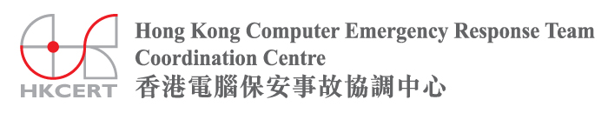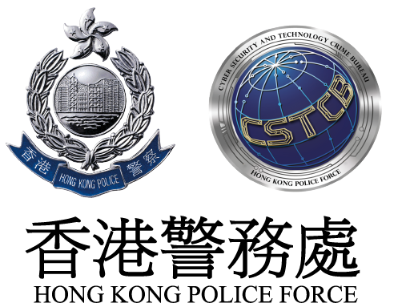

Co-organisers:


Supported by:
