Participant can choose to fill the online application form and submit entry through Internet. Please visit Cyber Security Information Portal (https://www.cybersecurity.hk/en/contest-2020.php) for details.

Participant Particulars:
Category: | Open  Category | Secondary  School Category | Primary  School Category

Name (Chinese)*: |  | (English)*:
Contact Number:
Email Address:
Name of School#: |  |  |  | Class#:
Name and Contact Number of Teacher#^:
* Chinese and English name should be identical to that appeared in HKID card
# Applicable to Secondary/Primary School Category only
^ “Name and contact number of teacher” are to facilitate the organisers to coordinate schools to receive “Most Supportive School Award” and attend the ceremony
Entry Details:
Name of the set of Stickers:
Introduction of the Stickers:
(Less than 200 words)

Terms and Conditions

How to Submit:
- Submission period: 7 September 2020 to 7 December 2020 (Late submissions will not be accepted)
- Submission by email: The completed and signed application form together with the entry files should be submitted by email and send to event@hkcert.org. Please mark “Secure Use of Mobile Devices – Sticker Design Contest” and the participating category in the subject field of the email.
- Submission by post or in person: This completed and signed application form, together with hand-drawn stickers, a DVD or other portable storage device containing the entry files, should be submitted either by post or in person to the following address during office hours (Monday to Friday: 9 am - 6 pm, except Saturday, Sunday and public holidays):

Hong Kong Computer Emergency Response Team Coordination Centre
HKPC Building,
78 Tat Chee Avenue, Kowloon

Please mark “Secure Use of Mobile Devices – Sticker Design Contest” and the participating category on the envelope.

Declaration:
- I have read and accepted the terms and conditions set out in the contest, which were stipulated on Cyber Security Information Portal (https://www.cybersecurity.hk/en/contest-2020.php).
- I declare that the entry submitted is original creation and not copied from or drawn by others.
- I agree that all copyright and other related rights of my entry belong to the organisers.
- I agree that the organisers reserve the final right of use of the entry.

 |  |  | Minor participant(s) (i.e. people aged under 18 on or before the submission deadline) should authorise his/her parents or guardians to consent the above declaration and Personal Data Collection Statement.
Signature of  Participant(s): |  |  | Signature(s) of  Parent/Guardian:
Date: |  |  | Name(s) of  Parent/Guardian:
 |  |  | Contact Number of Parent/Guardian:
 |  |  | Date:

Personal Data Collection Statement:
- The organisers’ primary goal in collecting and storing your personal data is for purposes relating to the activities of the Contest.
- Under general circumstances, the organisers will not sell, trade or disclose any information or personal data you provided to us to any third party without your prior consent or notice to you. Only authorised staff of the organisers has access to your personal information for administrative purposes without your authorisation or notice to you.
- Under special circumstances, the organisers shall have the right to disclose or release your personal data to any third party without your prior consent or notice to you. The said special circumstances include the protection of the rights, interests, copyright and intellectual property rights of the organisers, and the investigation or inquiry of illegal activities and any procedures required by law and the protection of the personal safety of the users and general public, etc.

Organisers:

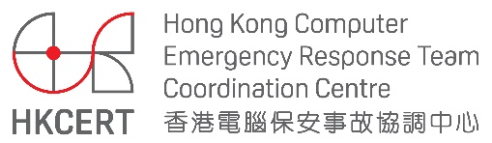

Co-organisers:

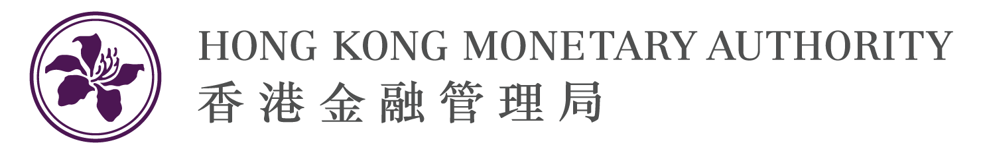

Supporting Organisations:

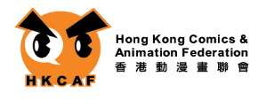

(For hand-drawn of the stickers, please use the following pre-printed form for drawing.)

Name of Participant (Chinese)*: |  | (English)*:
Name of the sets of Stickers:

